**Ultrasonic Security Camera**

*Max Barron – 2nd year Computer Engineering Technology Student at RIT*

*Jared Henry – 2nd year Computer Engineering Technology Student at RIT*

*James Paul – 2nd year Computer Engineering Technology Student at RIT*

**Motivation:**  Each of us has had a problem with security in some way in each of our respective rooms. After learning about the ultrasonic sensor in our microcontrollers lab, we decided to implement it into a design that could fix our security problems using an alarm, lights, and a camera to catch those who had been creating security threats.

**Project Description:** The system uses an ultrasonic sensor (part number HC-SR04) to detect a change in motion in order to set off an alarm using a speaker, an LED, and a camera (part number 0V264). The ultrasonic sensor can only detect motion when the device is set to active using an external interrupt that is triggered by a push button switch. Once motion is detected and the camera is activated, the photo is saved to an SD card and a message is sent via Bluetooth to the users phone.

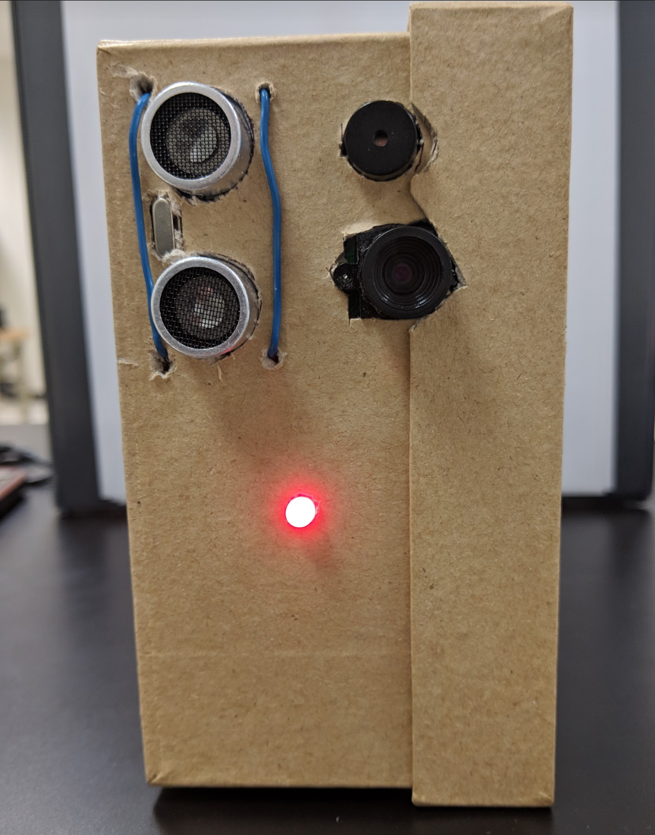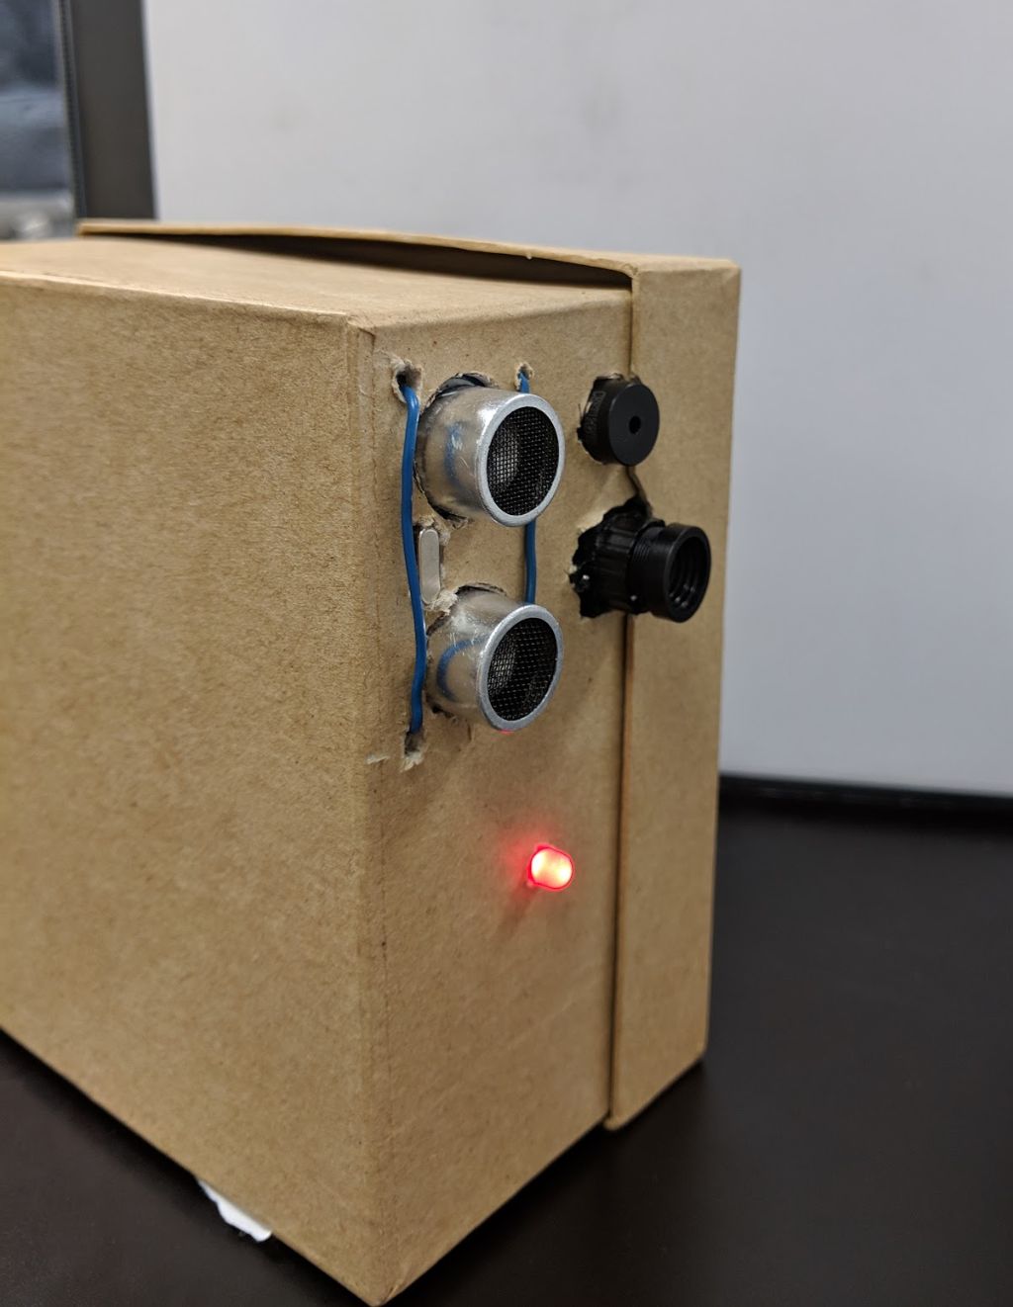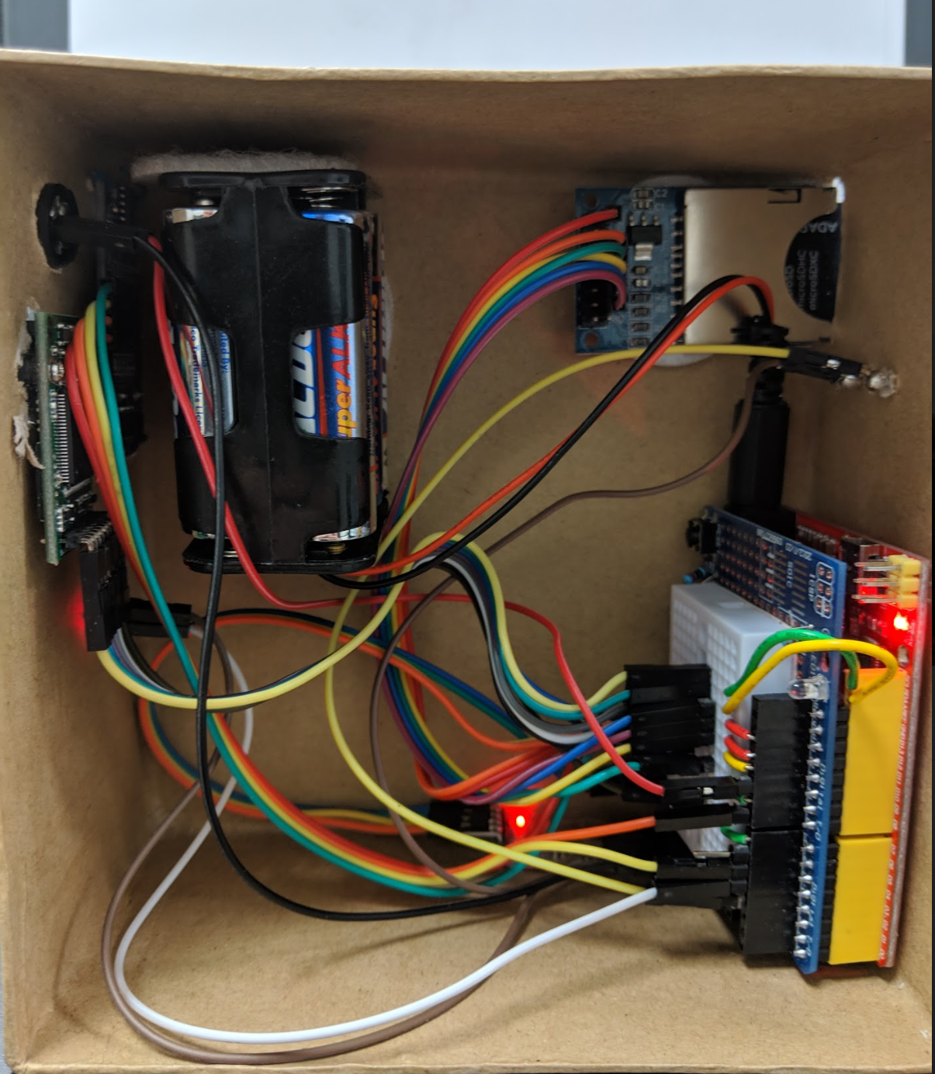

**Testing:** During testing we tried to find the maximum distance in which the device could be set away from a wall in order to not always detect the maximum distance. This included changing the timeout distance in the code to find the hardware limitations.

**Challenges:** With the high number of libraries and many lines of code needed to get the design to work, we found ourselves running low on memory as we approached our final product. Along with this, we began to run out of pins to connect the different components to the Arduino. Another problem we faced was understanding the library and software that came with the arduCam Camera. We were originally unable to figure out how to implement it into the code but after some research, we got the camera to be able to capture and even stream if connected directly to the computer. From there we were able to use it in conjunction with the SD Card reader.

**Meaning:** Once we had the final product finished, we were able to see that this could not only be used for us, but also anyone else facing security issues in their homes, at work, or even in a car. Another option is to be used in a track event to take a picture to determine the winner in a photo finish. The possibilities for the design are nearly endless.

**Possible Improvements:** One improvement that could be made in the future is the implementation of a smartphone app to go along with the design. This would allow the photo to be sent to a phone rather than just the message. Another option that would improve that even further would be to find a way to push the photo to your phone even if you are not in Bluetooth range. This would require some sort of cellular or WiFi enabler and may not be entirely possible with an Arduino. We would also like to streamline the product, creating a smaller case and a better battery solution.